Trade of Metal Fabrication
Module 1: | Basic Fabrication
Unit 8: | Heat Treatment
 | Phase 2

Table of Contents

List of Figures 5
List of Tables 5
Document Release History 6
Module 1 – Basic Fabrication 7
Unit 8 – Heat Treatment 7
Learning Outcome: 7
Key Learning Points: 7
Training Resources: 8
Key Learning Points Code: 8
The Practical Effects of Expansion and Contraction of Metals 9
Linear Expansion 10
Hardness Tests 12
Heat and Temperature Measurement 13
Colour Change of Metals (Approx.) 13
Heat Sensitive Indicating Paints and Crayons (Approx.) 14
Heat Cones or Pyramids (Seger Type) (Approx.) 14
Indicating Pellets and Dots (Approx.) 15
Liquid Expansion Thermometers (Precise) 15
Thermocouple Pyrometer (Precise) 15
Optical Pyrometer (Disappearing Filament Type) (Precise) 16
Transmission of Heat by Conduction, Convection and Radiation 17
By Conduction 17
By Convection 18
By Radiation 18
Heat Treatment 19
Annealing 19
Hardening 19
Tempering 20
Normalising 21
Carburising 21
Conversion between Celsius, Fahrenheit and Kelvin 22
Self Assessment 23
Questions on Background Notes – Module 1.Unit 8 23
Answers to Questions 1-4. Module 1.Unit 8 24
Index 26

List of Figures
Figure 1 - Expansion Bends 10
Figure 2 - Heat Cones or Pyramids 13
Figure 3 - Thermocouple Pyrometer 14
Figure 4 - Optical Pyrometer 15
Figure 5 - Transfer of Heat 16
Figure 6 – Conduction 16
Figure 7 – Convection 17
Figure 8 – Radiation 17

List of Tables
Table 1 - Value of Coefficient of Linear Expansion 8
Table 2 - Colour Change of Metals 12
Table 3 - Good and Bad Conducting Materials 16
Table 4 - Quenching Colours 19

Document Release History
Date | Version | Comments
16/08/06 | First draft
13/12/13 | SOLAS transfer

Module 1 – Basic Fabrication

Unit 8 – Heat Treatment
Duration – 4 Hours

Learning Outcome:
By the end of this unit each apprentice will be able to:
- Describe the purpose of hardening and tempering of carbon steels
- Describe the procedure for hardening and tempering of carbon steels
- State the principles of hardness tests, (a) Brinell, (b) Vickers, (c) Rockwell

Key Learning Points:
Sk | Forge forming standard hand tools.
Sk Rk | Hardening and tempering – methods and purpose.
Sc Rk | Procedures and principles of hardness tests and the difference between (a) Brinell, (b) Vickers and (c) Rockwell.
Rk Sc | Descriptions of Conduction, Convection and Radiation heat.
Rk M | Temperature and scales – Measurement of temperatures.
M Sc | Conversion between Celsius, Fahrenheit and Kelvin.
Rk Sc | Coefficient of linear expansion – effects of heat on steel.
Sk | Use of rose heating torch.
P | Communication – information gathering.

Training Resources:
Fabrication workshop facilities, P.P.E.
High carbon steel, tongs, hammer, handouts, transparencies.
Classroom samples of hardness tests.

Key Learning Points Code:
M = Maths D= Drawing RK = Related Knowledge Sc = Science
P = Personal Skills Sk = Skill H = Hazards

The Practical Effects of Expansion and Contraction of Metals
When metals are heated they expand and increase in length. Similarly, when cooled they contract. The amount by which they expand or contract depends on three factors:
- How long they are to start with - as you would expect, a bar twice as long as another will expand twice as much.
- The amount the temperature changes - bigger changes in temperature will give greater changes in length than smaller temperature changes.
- The type of metal - different metals expand at different rates. A constant value for each material is available. It is called the Coefficient of Linear Expansion (see table below).
Change of length = Original length x
Coefficient of Linear Expansion x
Temperature change.
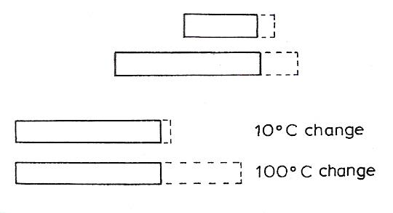
Metal | Value (ºC)
Aluminium | 0.000028
Brass | 0.000020
Copper | 0.000017
Steel | 0.000012
Cast Iron | 0.000016
Table 1 - Value of Coefficient of Linear Expansion

Example:
If a steel plug, gauge 50.00 mm diameter, has its temperature raised from 20°C to 27°C, what will be its new diameter at this temperature?
Coefficient of Linear Expansion (from table) = 0.0000112
Change of temperature = 27 - 20 = 7°C
Change in diameter = 50.00 x
0.0000112 x 7
= 0.0039 mm
New diameter at 27°C = 50.00 + 0.0039
= 50.0039 mm.
This property of metal to expand and contract can be used to advantage or disadvantage, as follows:
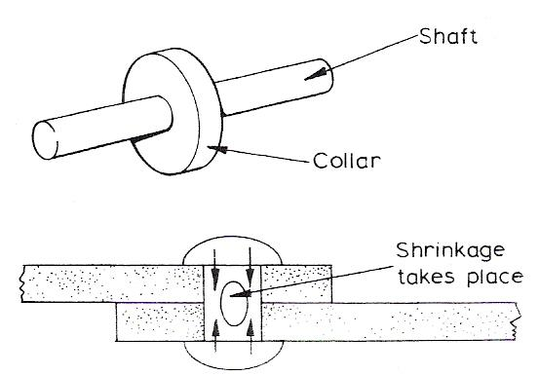
Used to Advantage
- It can be used to shrink components together, such as a shaft or collar which has an interference fit. The collar is heated, it expands and slips on to the shaft; when it cools it shrinks and fits tightly on the shaft.
- After heat-riveting has taken place the centre of the rivet is still hot and, on cooling, tends to shrink and pulls the plates together.

Linear Expansion
If a bar of steel is heated uniformly in a furnace it will expand naturally in all directions if it is not restrained in any way. If allowed to cool evenly and without restraint it contracts to its original shape and size without distortion.
If the original dimensions, the rise in temperature and the expansion of the metal block are measured, it will be found that they are related to each other. Thus, for a given metal:
- The expression is proportional to the rise in temperature.
- The expansion is proportional to the original size of the component.

Expressed mathematically this gives the formula:
x = l α t
where
x = increase in size
l = original length
α = coefficient of linear expansion
t = rise in temperature

Expansion in long straight runs of pipeline can cause problems, as the following example illustrates:
Example:
A straight length of copper pipeline measures 30 metres at room temperature (15ºC). After hot water has been passing through it for some considerable time, its temperature is raised to 60ºC. Calculate its increase in length.
x = l α t
= 30 x 0.000017 x (60-15)
= 30 x 0.000017 x 45
Increased length = 0.02295 metres = 22.95 mm

An increase in length of 23mm is quite substantial; therefore pipelines for carrying steam or hot liquids require special provisions to compensate for expansion. Figure 1 shows some typical examples of expansion bends, which can be introduced into pipeline systems.
There are some engineering operations where the expansion of metals can be used to advantage. When a metal ring or hoop is heated and placed over another part, the resultant contraction, upon cooling, will ensure an extremely tight fit with the encircled part. This is known as ‘shrink fit’ and is used, for example, when fitting a steel tyre to the rim of a locomotive wheel.

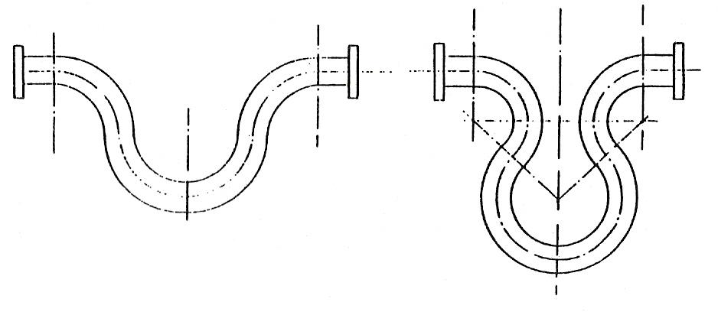
Figure 1 - Expansion Bends

Hardness Tests
The most common hardness tests are those in which an indentor is forced into the surface of the material under test. Some methods use the surface area of the indentation as the index of hardness.
The Brinell test is typical of the first group. In this test, a hardened steel ball is forced into the surface of the material under a standard load, which is maintained for 15 seconds to ensure that plastic flow is completed. The specimen is removed and the diameter of the impression is measured with a low-power microscope fitted with a graticule or measuring scale. The diameter is then compared with a table, from which the hardness is read off: the smaller the impression, the higher the number. This test is suitable for materials with a low or medium hardness.
The Vickers diamond pyramid test is similar to the Brinell test, but it employs a small diamond of pyramid shape, instead of a steel ball. It produces more reliable results for high hardness materials, but identical values for softer materials.
The Rockwell machine forces a specially shaped indentor, termed a ‘brale’ into the material and automatically records the depth of the impression. The hardness number is then read on a dial on the machine. The Rockwell test is very quick and is suitable for mass inspection of parts.
It should be noted that these tests indicate only the surface hardness qualities.

Heat and Temperature Measurement
There is a fundamental difference between temperature and quantity of heat. An example which explains the difference would be the temperature of a candle flame and the temperature of a bucket of warm water. One burns the hand and the other does not. Yet despite the higher temperature of the candle it would take hours for it to warm the bucket of water, indicating that there is a greater quantity of heat in the water despite its lower temperature. Obviously the length of time of heating (quantity of heat) is more significant than the temperature of the heating medium.
When the temperature of a heated component is to be measured, it is important that we know whether an approximate or precise measurement is required and whether a comparatively low or high temperature is to be measured. The following is a selection of the more common methods used in fabrication and welding.

Colour Change of Metals (Approx.)
Steel when heated passes through noticeable colour changes as its temperature alters and this enables an approximate temperature to be estimated (See Table 2). Other metals such as copper and its alloys only show a dull red to light orange. Cast iron becomes a dark red, but aluminium has no noticeable colour change.
Applications Forging. Quenching. Pre-heat.
Colour | Approximate Temperature (ºC)
Brilliant white  Bright white  White  Bright orange  Orange  Bright cherry red  Cherry red  Brilliant red  Dull red  Faint red | 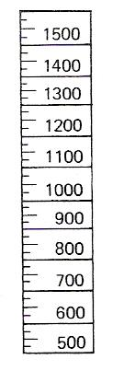
Table 2 - Colour Change of Metals

Heat Sensitive Indicating Paints and Crayons (Approx.)
These work on the principle that mixtures of mineral oxides and pigments will change colour or melt on heating. The surface should be free from rust, dirt and grease. The paint should be applied by brush or alternatively a "tempilstick" crayon may be used which is simply stroked on the job and melts at the stated temperature. They range in calibrated steps from 30°C to 1600°C.
Paints and crayons are used to estimate the temperature of the actual component and not the surrounding temperature. They must not be heated directly as the heat from the metal should cause the colour change. There is the reversible type which, for example, changes from red to black at 70°C and upon cooling reverts to its original colour, red, and the change being instantaneous. These are used normally on non-metals. Metallic surfaces should be cleaned and lacquered to avoid contact between paint and metals when this type is used on metal.
The non-reversible type changes colour, e.g. red to green at 800°C and remains that colour regardless.
The "tempilsticks" are marked with the change temperature. Colour changes are indicated for paints. They range in temperature from 80 to 1400°C.
Applications Pre-heat heat treatment.
An extension of this principle is the use of white soap or matchsticks used to judge the pre-heat temperature of aluminium. The aluminium is rubbed with either the soap or matchstick and the temperature estimated from the resulting brown mark. Light brown approx 300°C, dark brown 400°C.

Heat Cones or Pyramids (Seger Type) (Approx.)
These are pyramids of mixtures of elements such as Kaolin Lime, etc., varied to give a range of melting temperatures so that the top of the pyramid arches over to touch its base, indicating that the temperature has been reached (Figure 2). Three are usually used with approx. 20°C difference in temperature between each, the middle one being the required temperature. Temperature range between 400 and 2000°C.
Application Used in fabrication for furnace heating aluminium and magnesium alloys. Kilns for bricks, pottery, etc.
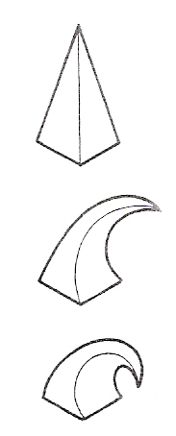
Figure 2 - Heat Cones or Pyramids

Indicating Pellets and Dots (Approx.)
A similar material of manufacture as crayons and paints. The pellets and dots melt immediately at their specified temperature with an error of not more than ± 1 % at temperatures ranging from 45°C to 900°C. The dots are stuck in position.
Applications Assessing the temperature distribution of turbine blades under test conditions.

Liquid Expansion Thermometers (Precise)
These thermometers of the mercury-in-glass or mercury-in-steel type work on the principle that the heated mercury expands up a fine bore capillary tube calibrated in ºC. With the mercury-in-steel type, the capillary tube is flexible and connected to a Bourdon-type gauge. All air is exhausted from the capillary tubes at manufacture and the ends sealed. The mercury-in-glass measure up to 340°C and in steel up to 395ºC.
Applications Temperature of liquids, mounting resins, fats, room and workshop temperatures.

Thermocouple Pyrometer (Precise)
If two different metals such as platinum and platinum/rhodium are joined together (surrounded by a refractory sheath for protection) and heated at the joint, and the other end kept cold, then a voltage is set up in the circuit. This is called an electromotive force (e.m.f.). A millivolt meter which is calibrated to read °C is connected into this electrical circuit which will measure the e.m.f. The value of the e.m.f. is proportional to the temperature of the joint. The temperature may be read directly from the meter. The temperature range depends upon the type of dissimilar metals used but temperatures up to 1600°C may be measured.
Applications Furnace temperatures for annealing, normalising and stress relieving. Molten metals.

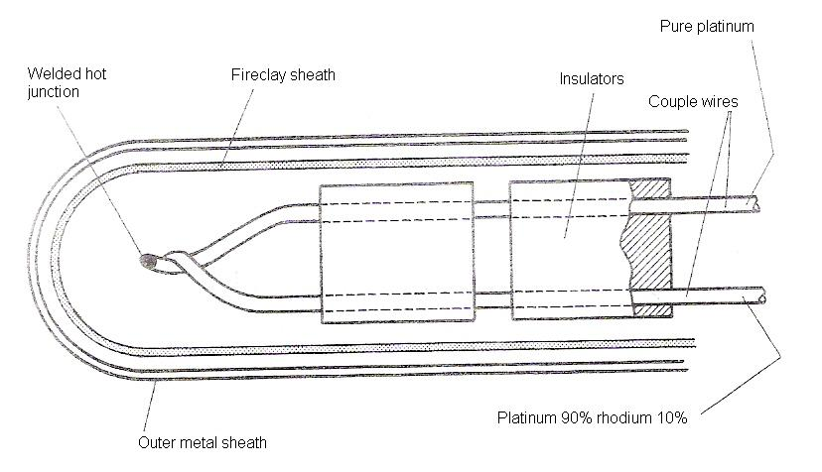
Figure 3 - Thermocouple Pyrometer

Optical Pyrometer (Disappearing Filament Type) (Precise)
This type compares the intensity of light radiated from the heat source with a known heat source.
The most common type is the disappearing filament type. An electric bulb filament is sighted against the hot body being measured. Current is passed through the filament causing light to be emitted. The current is adjusted by means of a variable resistor until the colour of the hot body and the filament colour just match, causing the filament to disappear. An ammeter measures the current used by the filament and is calibrated so that the temperature may be read directly. Flames and smoke cause variable readings. Temperatures in the range 700 to 1800°C may be measured.
Applications Furnace roofs and walls for collapsible hot spots.
Molten metals. Heat treatment.

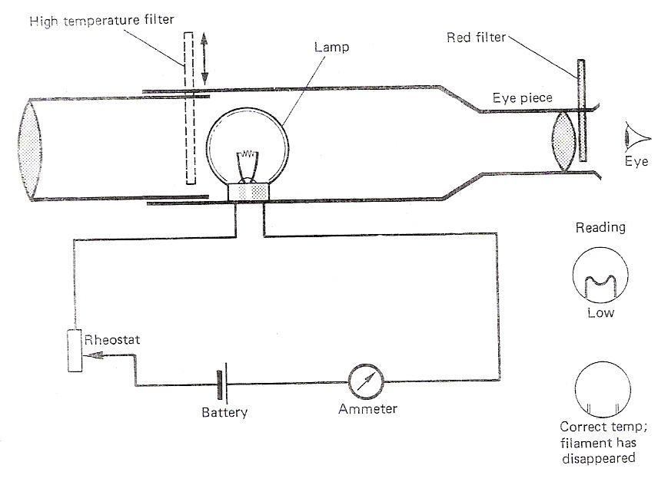
Figure 4 - Optical Pyrometer

Transmission of Heat by Conduction, Convection and Radiation
If a block of metal is placed in a furnace and allowed to become white hot and is then taken from the furnace and placed on a metal work surface it will eventually cool down. The cooling takes place in three ways.
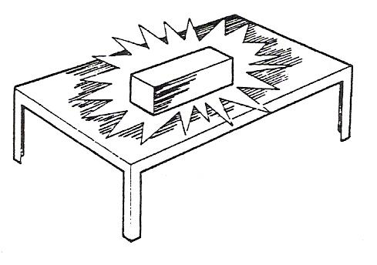
Figure 5 - Transfer of Heat

By Conduction
Because it is in contact with the work-bench top, heat will be transferred from the block to the top and will gradually heat up this surface. Although no movement takes place it is as though the heat is flowing from one particle of the material to the next. Different materials conduct heat at different rates: metals tend to be good conductors whereas non-metallic materials tend to be bad conductors.
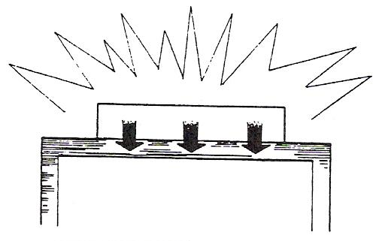
Figure 6 – Conduction

Good Conducting Materials |  | Bad Conducting Materials
Silver | Zinc | Wood | Ice
Copper | Tin | Wool | Sand
Gold | Iron | Asbestos | Earth
Aluminium | Steel | Paper | Plastics
Brass | Lead | Water | Porcelain
Table 3 - Good and Bad Conducting Materials

By Convection
Transfer of heat by convection can take place in either gases or liquids.
The air in contact with the block is heated and expands, reducing its density. Because it is now lighter than the air above it, it will rise allowing the cooler air to take its place. This air in turn will expand and rise and be replaced by more cool air.
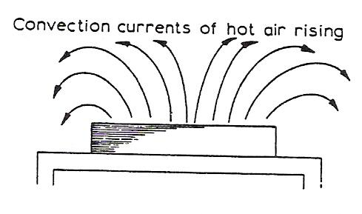
Figure 7 – Convection

By Radiation
Radiation is heat transferred in the form of waves (similar to light waves) travelling through the intervening space. If you were to stand a short distance away from the block you could feel this radiated heat on your exposed skin.
In the case of an electric fire the glowing element radiates heat which is then reflected forward into the room by a polished reflector.
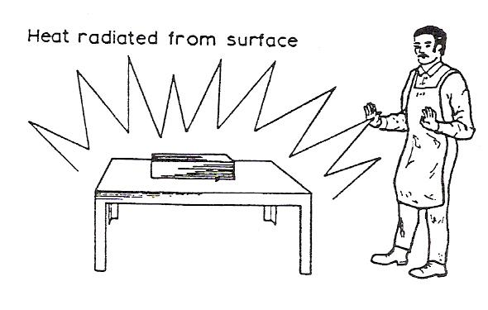
Figure 8 – Radiation

In most cases when objects cool down it is by a combination of two or more of the above methods acting at the same time.

Heat Treatment
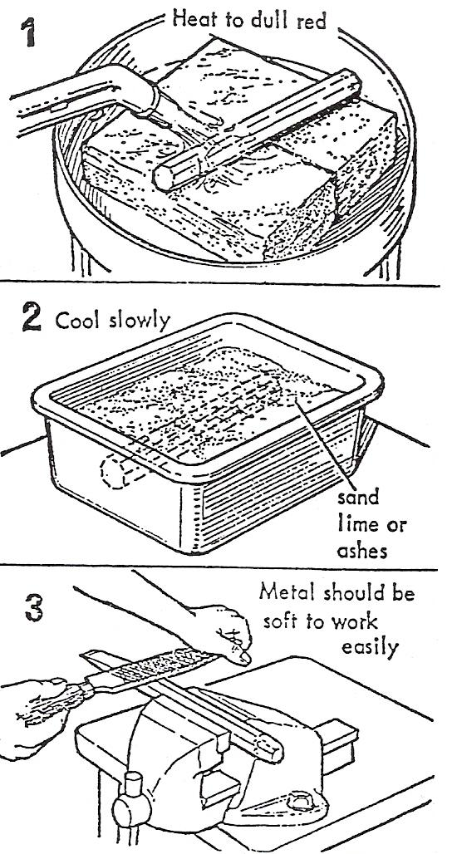
Heat treatment is a term used to describe a process of changing the properties of a metal by careful heating and cooling. For hand tools and small work pieces, the work can be done in the workshop forge.

Annealing
This process makes a metal soft and workable. The diagrams show the process of annealing a bar in order to make a chisel.
- The bar is heated.
- The hot bar is cooled slowly in sand.
- The bar is worked to shape.
Metals can become hard when they are struck repeatedly - this is called "work hardening". Work hardened metals are restored to their original state by annealing.

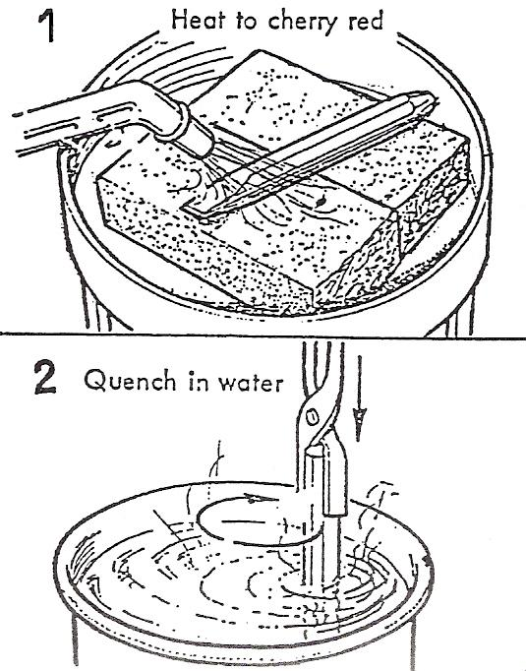
Hardening
This chisel shape needs to be hard in order to cut.
The diagrams show the process of hardening by:
- Heating to cherry red.
- Quenching water.
The workpiece should be plunged vertically into the water, and moved rapidly to ensure uniform cooling and prevent cracking. When quenching jobs of irregular shape, the larger end should always be quenched first.

Tempering
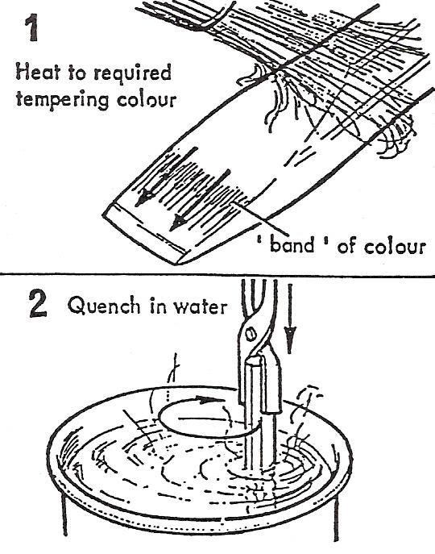

When metal is hardened, it sometimes becomes brittle. This can be reduced by tempering.
The part is cleaned to bare metal. (This ensures easy recognition of colour changes, when the metal is heated.)
- Heat the metal. The first colour to appear is yellow, followed by brown and finally blue.
- Quench the metal in water immediately the right colour is reached.

Colour | Type of Article
Pale Straw | Scrapers and scribers
Deep Straw | Drills
Yellow-brown | Punches, pipe-cutters
Purple-brown | Rivet snaps, plane irons
Purple | Axes, press tools
Deep purple | Cold chisels
Deep blue | Springs
Table 4 - Quenching Colours

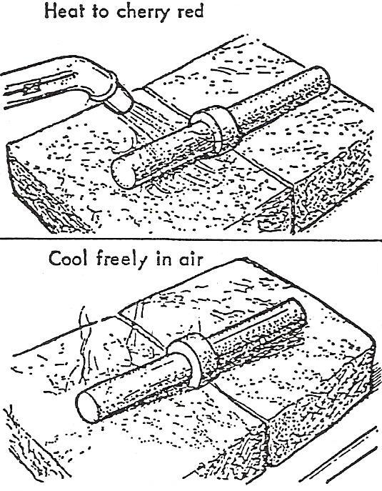
Normalising

Normalising is used to return a metal to its normal condition after it has been forged or improperly heat treated.

The metal is heated to the same temperature as for hardening and then cooled freely in air.

Carburising
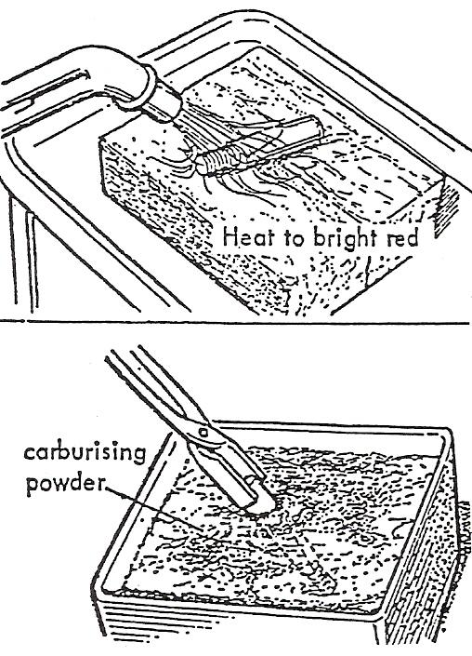

Mild steel is not easy to harden when mild steel components must have a hardened surface. This can be achieved by carburising!
The component is heated to bright red and dipped in a carbon-rich mixture. The component absorbs carbon into its surface layer. Heating and dipping is repeated two or three times to ensure hardness to sufficient depth.

Conversion between Celsius, Fahrenheit and Kelvin
Convert 86ºF to C:
C = 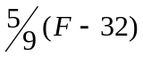
= 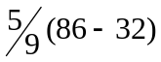
= 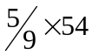
= 30ºC

Convert 20ºC to F:
F = 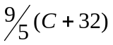
= 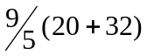
= 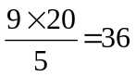
= 36 + 32
= 68ºF

Self Assessment

Questions on Background Notes – Module 1.Unit 8

1. By way of a Diagram or briefly explain what Batch Cutting is.

2. Why is Tempering the blade on a Band Saw recommended?

- When replacing a Saw Blade in the Band Saw which direction should the teeth
face?

4. List three points of Safety when operating the Band Saw.

Answers to Questions 1-4. Module 1.Unit 8

1.

Round Material Bundle

Square Material Bundle

Angled Material Bundle

2.

Tempering the blade or running it in as it is sometimes called
pro-longs the life of the blade.

3.

Forward.

4.

1. Wear Eye Protection.

- Most machines emit noise levels to 80DB. Wear Ear Protection.

- If the machine is running you must not wear Gloves/ Lose fitting
Clothing or Rings, as there is a danger of getting caught up with
the cutting blade.

Index

C
Conversion between Celsius, Fahrenheit and Kelvin, 21
H
Hardness Tests, 11
Heat and Temperature Measurement, 12
Colour Change of Metals (Approx.), 12
Heat Cones or Pyramids (Seger Type) (Approx.), 13
Heat Sensitive Indicating Paints and Crayons (Approx.), 13
Indicating Pellets and Dots (Approx.), 14
Liquid Expansion Thermometers (Precise), 14
Optical Pyrometer (Disappearing Filament Type) (Precise), 15
Thermocouple Pyrometer (Precise), 14
Heat Treatment, 18
Annealing, 18
Carburising, 20
Hardening, 18
Normalising, 20
Tempering, 19
L
Linear Expansion, 9
T
The Practical Effects of Expansion and Contraction of Metals, 8
Transmission of Heat by Conduction, Convection and Radiation, 16
By Conduction, 16
By Convection, 17
By Radiation, 17

